**Time Series Analysis - Manufacturing Sector**

GOKULNATH K & E24755

**Overview**

Time series analysis in manufacturing analyzes time-ordered data like production output, machine performance, or inventory levels. It identifies trends, seasonal patterns, and anomalies to optimize processes and predict future needs. This helps improve forecasting, reduce downtime, and enhance decision-making. It is commonly used for predictive maintenance, demand planning, and resource allocation.

**Objective**

1. **Demand Forecasting:** Optimize production schedules and inventory to prevent overproduction or stockouts.
2. **Predictive Maintenance:** Forecast equipment failures for timely maintenance and reduced downtime.
3. **Quality Control:** Detect product quality deviations early to improve consistency.
4. **Production Optimization:** Identify bottlenecks and enhance resource allocation.
5. **Inventory Management:** Forecast inventory needs to reduce holding costs and ensure availability.
6. **Cost Reduction:** Identify cost-saving opportunities by analyzing trends in energy consumption, raw material usage, and labor efficiency over time.
7. **Supply Chain Optimization**: Predict material delivery schedules and align production with supply chain efficiency to prevent delays or disruptions.

**Assigned Task(s)**

* Time Series Analysis - Manufacturing Sector

**Task Details**

* **Task 30 :** Time series analysis is a statistical method that helps analyze data points collected at regular intervals over a set period of time. It can be used to identify patterns, trends, and irregularities in the data, and to forecast future data points.
* **Status:** Completed.
* **Details:**

1. Resampled daily data into monthly averages for easier analysis.
2. Visualized time series trends for production, downtime, and utilization.
3. Calculated 6-month rolling averages to highlight trends.
4. Analyzed correlations between production, downtime, and utilization.
5. Built a linear regression model to forecast production units.
6. Compared actual vs. predicted production using visual plots.
7. Measured prediction accuracy using Mean Absolute Error (MAE).

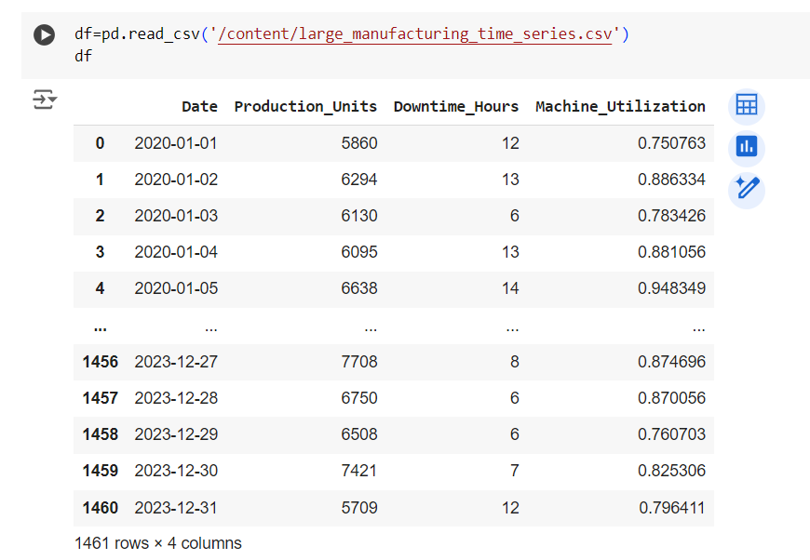

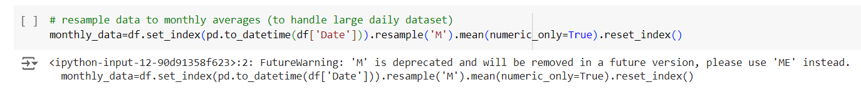

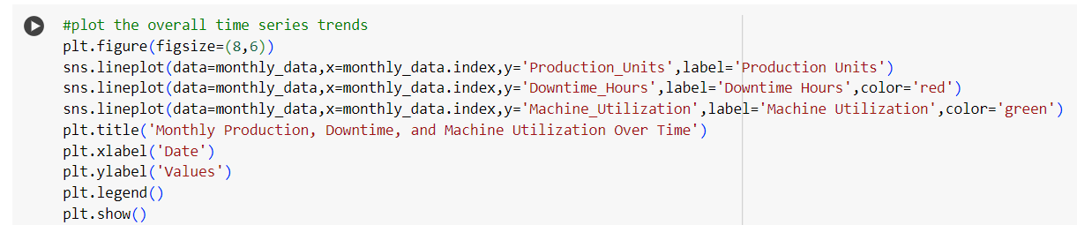

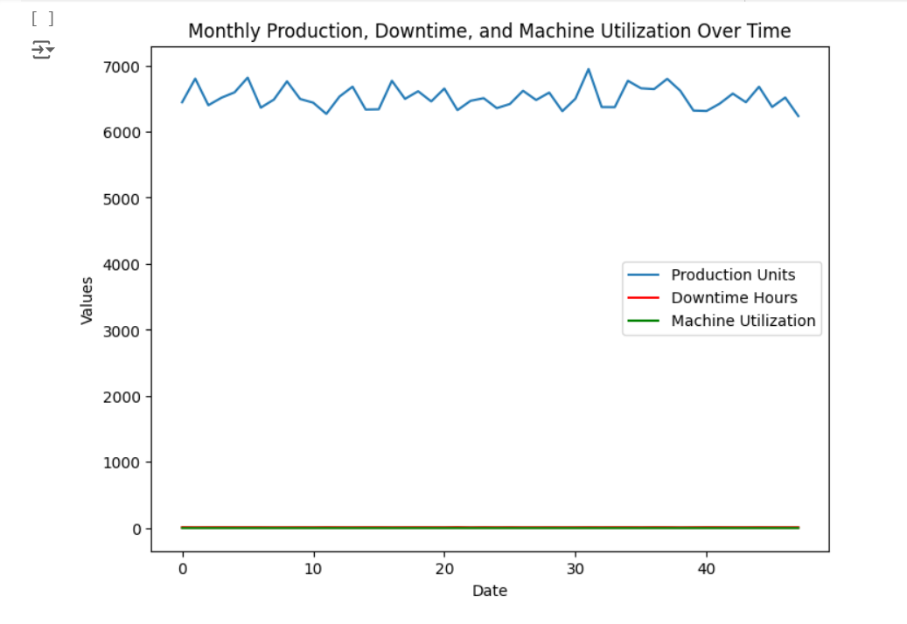

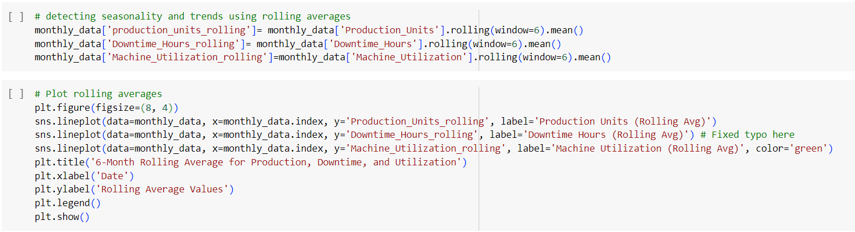

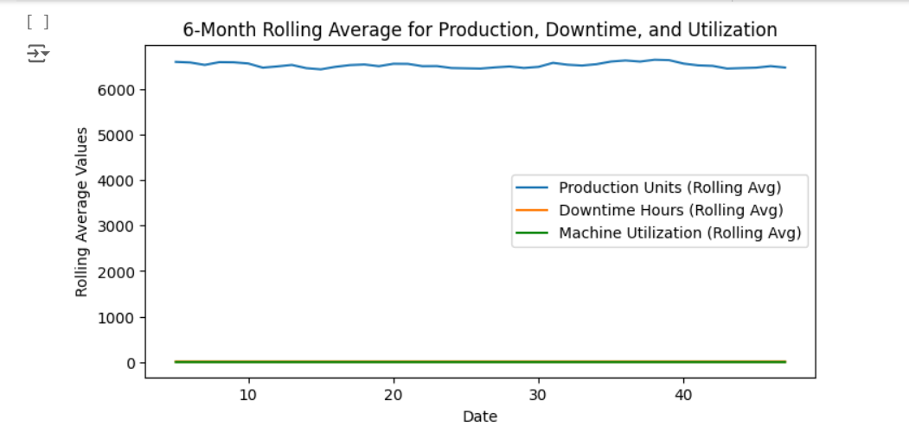

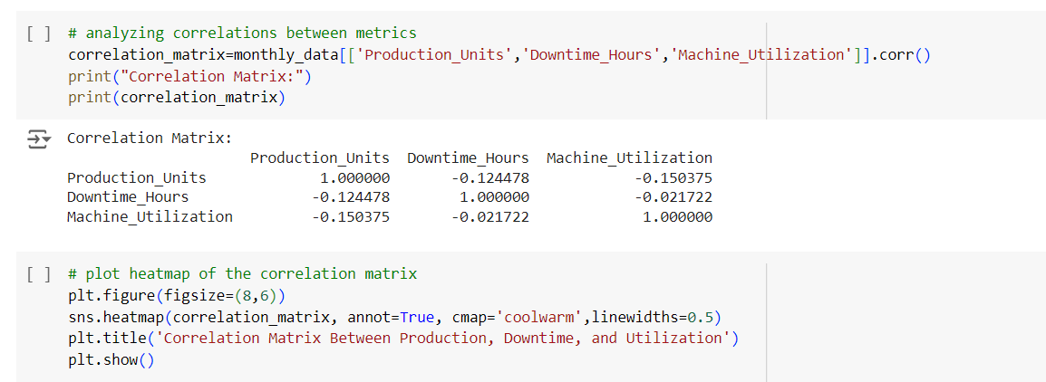

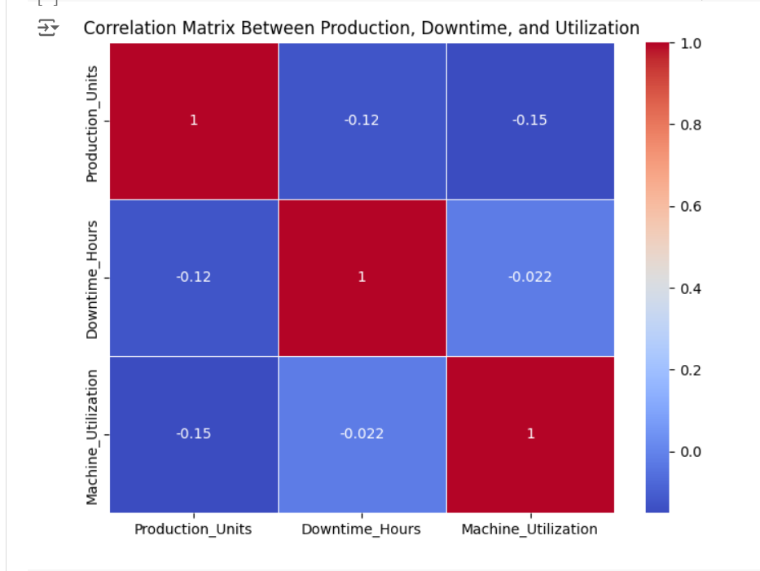

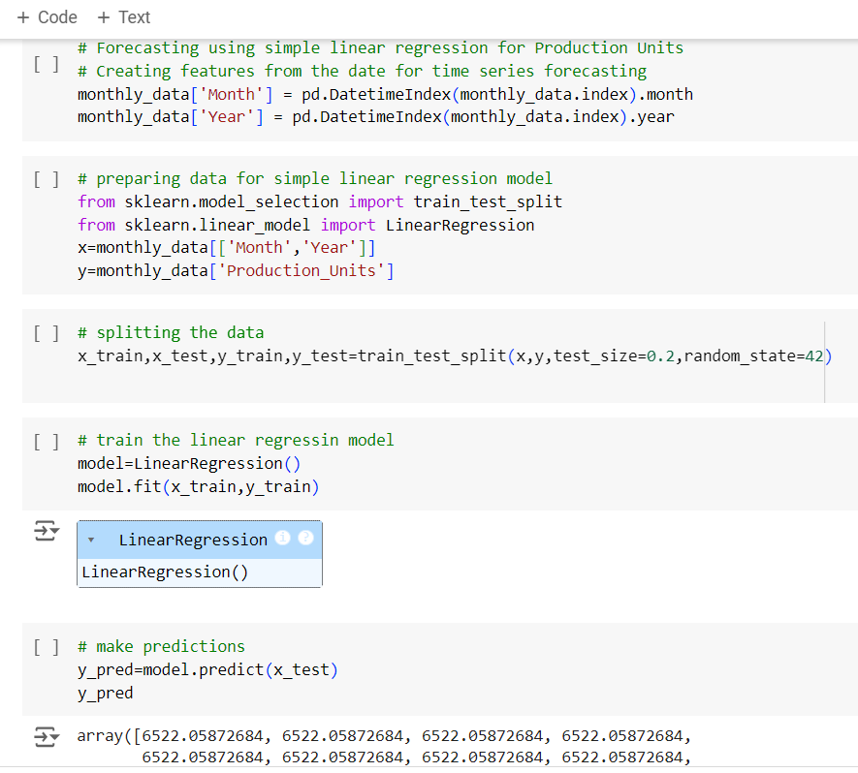

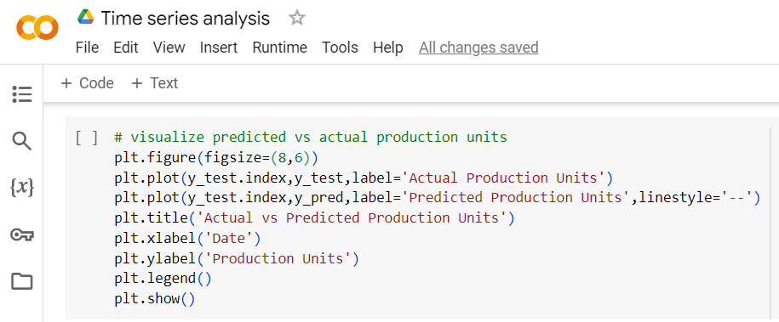

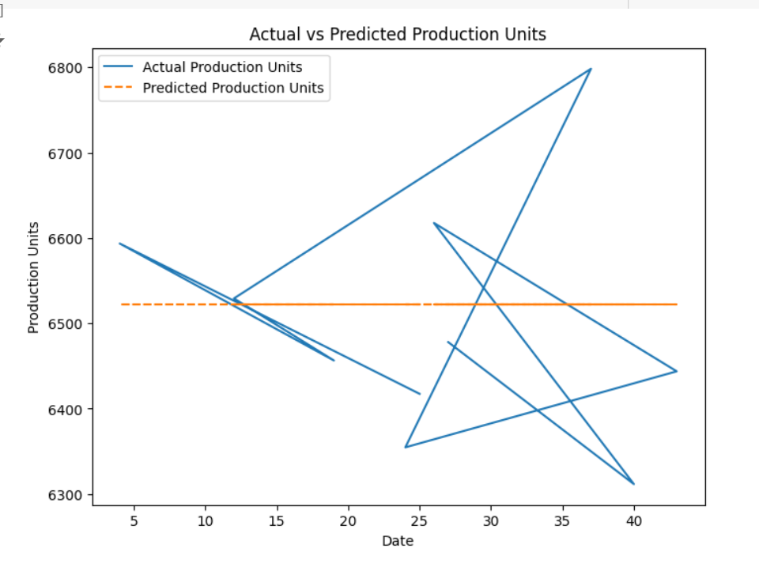

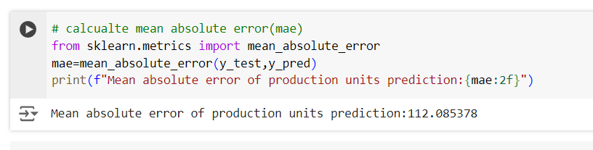

**Progress**

* **Accomplishments:**

1. Simplified data analysis by resampling daily data into monthly averages.
2. Identified key trends in production, downtime, and machine utilization through visualizations.
3. Highlighted long-term patterns using rolling averages for better decision-making.
4. Revealed strong correlations between production, downtime, and utilization for performance insights.
5. Developed a predictive model to forecast production units based on historical data.
6. Enhanced forecasting accuracy by comparing actual vs. predicted values with low error.

* **Metrics:**

1. Monthly Production Units: Aggregated average production units per month.
2. Monthly Downtime Hours: Aggregated average downtime hours per month.
3. Machine Utilization Percentage: Average utilization rate of machines per month.
4. 6-Month Rolling Averages: Smoothed values for production, downtime, and utilization over a 6-month period.
5. Correlation Coefficients: Relationships between production, downtime, and machine utilization.
6. Mean Absolute Error (MAE): Accuracy of the linear regression model in predicting production units.

**Challenges and Solutions**

* **Challenges Faced:**

1. Handling large daily datasets: Required resampling to simplify analysis.
2. Fluctuations in data: Difficult to observe long-term trends due to short-term variations.
3. Correlation complexity: Identifying meaningful relationships between multiple variables.
4. Prediction accuracy: Ensuring accurate forecasting with a simple regression model.

* **Solutions Implemented:**

1. Resampled to monthly data: Made the dataset manageable and easier to analyze.
2. Used rolling averages: Smoothed out fluctuations to reveal long-term patterns.
3. Applied correlation analysis: Identified key variable relationships.
4. Developed a regression model: Forecasted production units effectively with acceptable error.

**Next Steps**

* **Upcoming Tasks:** Set clear objectives, prioritize tasks, break down projects, establish a timeline, and stay organized to effectively tackle upcoming tasks.
* **Goals:** define smart goals, adaptable, seek feedback, and maintain a positive mindset to effectively achieve upcoming goals.

**Conclusion**

* **Summary:** The time series analysis in the manufacturing sector revealed critical trends in production, downtime, and machine utilization, enhancing data-driven decision-making. By utilizing rolling averages and linear regression for forecasting, the analysis provided valuable insights into operational efficiency. Overall, this approach enables proactive management strategies that can significantly improve manufacturing performance.
* **Acknowledgments:** Thank you all for your attention and engagement, I appreciate your interest in the Time Series Analysis in Manufacturing sector.